Product Specification

07/2013
Product | Middle install intelligent LCD Display
Mode | APT12LCD800S
Abbreviation | 800S
Client
Customer audit
Supplier | dong guang shi tongfu Technology Co., Ltd.
xin yuan yi lu 6 hao chuang yi chan ye yuan B211 shi
da liang zhen chong fu she qu
dong guan
guang dong
523778
CN
Tel | TEL:+86 13790321373
website | www.pswpower.com

- Product Name
  - The Middle install intelligent LCD Display
  - Model:APT12LCD800S
- Suppliers
dong guang shi tongfu Technology Co., Ltd.
- Electrical Parameters
  - 24V/36V battery supply
  - Rated operating current : 10mA
  - Max operating current : 30mA
  - Off leakage current < 1uA
  - Max output current to controller : 50mA
  - Operating temperature : -28～70℃
  - Storage temperature : -40～70℃
- Dimensions & Material
  - Product shell is ABS, transparent window is made with high strength Acrylic, the stiffness equals the tempered glass.
  - Dimensions : host/L90mm*W54mm*H13.3mm
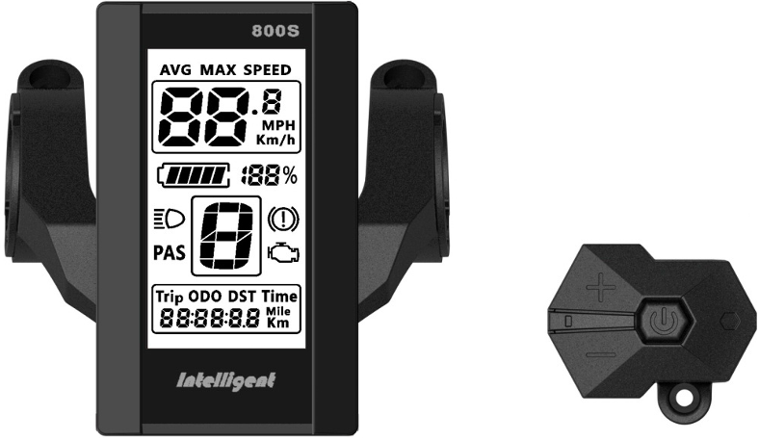
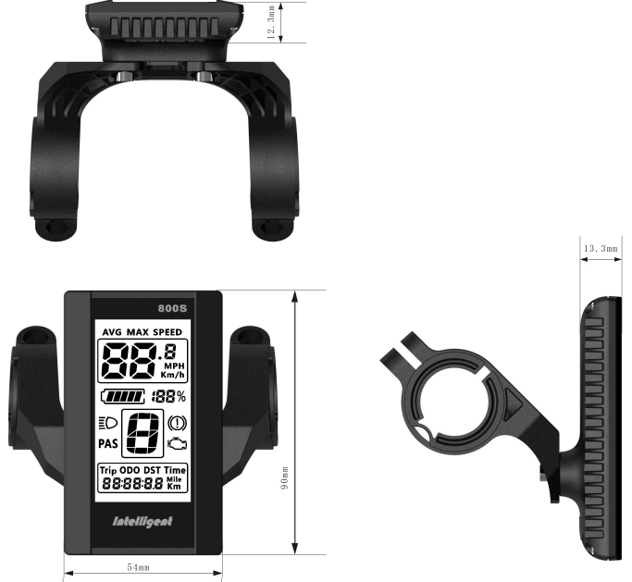
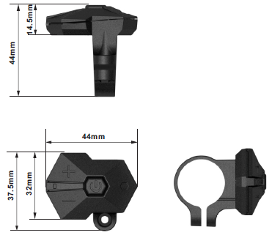
- Features
  - Suitable for low temperature，Max -28℃.
  - Ergonomic external button design, easy to operate.
  - Speed display : AVG SPEED, MAX SPEED, SPEED(Real-time).
  - Kilometer / Mile : Can be set according to customers’ habits.
- Smart battery indicator : Provide a reliable battery indicator, it will not fluctuate with the motor on/off.
- The brightness of the backlight adjustable : 5-sections
- 9-level Assist : 3-level/5-level/6-level/9-level... optional
- Mileage indicator : Odometer/Trip distance/ Riding time
- Error code indicator
- Parameter settings : Multiple parameter can be set through computer USB port, including assist level numbers/ Wheel diameter / Voltage / Speed limit…
- LCD instructions
The figure of LCD display see below:
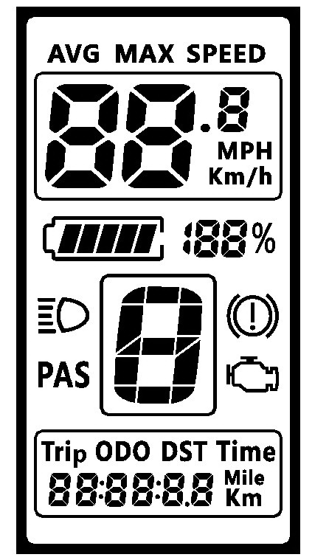
Speed mode
Lamp
Battery indicator
PAS level
Mileage mode
Mileage information
Speed display
ERROR code
Brake
- Functional Description
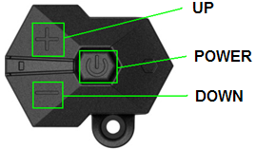
  - Power On/Off
Press and hold Power button for 1 second can turn on/off the display. The Display can automatically shut down when there is no operate & ride for n minutes（n could be 0~9）.
  - Assist level operating
Short press UP/DOWN button can change the assist level. Top assist level is 9, 0 for neutral. Level quantities can be adjusted according to the customer requirements.
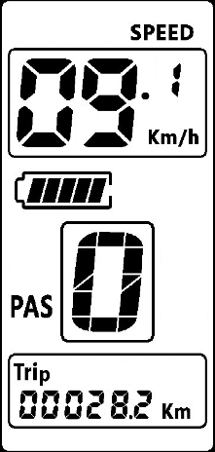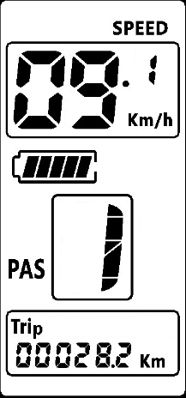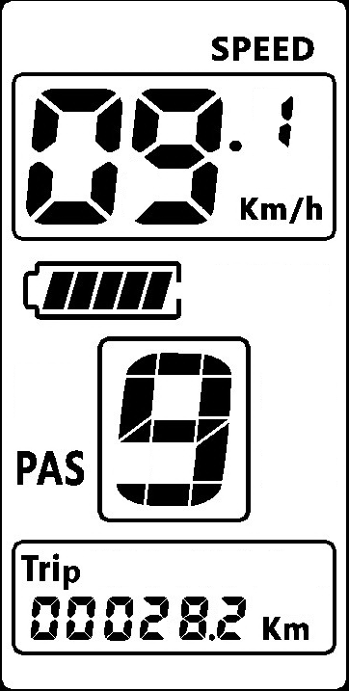
Assist operating
  - Speed mode switch& Mileage mode switch
Short press POWER button can change the speed mode& the mileage mode, Speed->AVG Speed->MAX Speed->Trip->ODO-> Time.
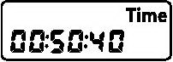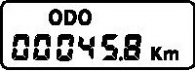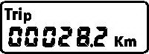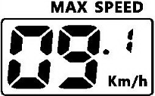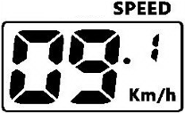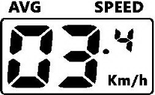
Time
ODO
Trip
MAX speed
Speed
AVG speed
Speed mode switch& Mileage mode switch
*If there is no operation for 5 seconds, display will return Speed (Real-Time) display automatically.
  - Headlight/backlight On/Off
Press and hold UP button for 1 second can turn on/off the headlight/backlight.
The motor does not work when the battery voltage is low, Display still can keep the headlight on for a while when E-bike is in riding.
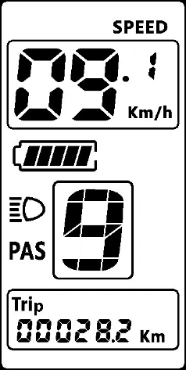
  - 6km walk
Press and hold DOWN button for 1 second can get into walk mode, out of the mode when release the button.
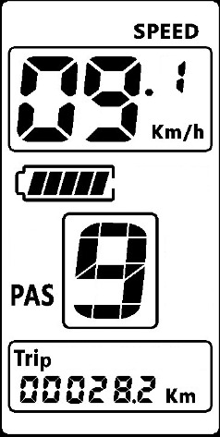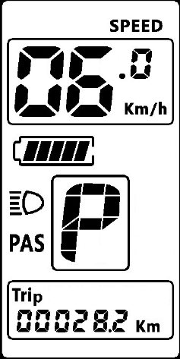
  - Data cleanup
Press and hold UP & DOWN buttons together for 1 second can reset several temporary data, temporary data include AVG Speed / MAX Speed / Trip / Time.
- Parameter setting
Double press POWER button(press interval less than 0.3 second) can get into parameter setting state, the parameter twinkles. Short press UP/DOWN buttons to change the parameter value, short press POWER button can switch to the next parameter. Double press POWER button(press interval less than 0.3 second) can quit from the parameter setting state. The display will automatically quit the parameter setting state when there is no operation for 10 seconds.
The order of parameters is as follows.
Backlight
Brightness
Auto off time
Wheel diameter
Voltage set
Speed limit set
Kilometer/Mile
Password
  - Kilometer / Mile : The location of speed displays symbol S7, press UP/DOWN button rotate display the symbol km/h / MPH (Km / Mile)
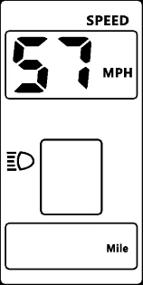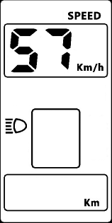
  - .Backlight brightness : The location of speed displays symbol bL1, press UP/DOWN button display symbol 1~5 to change the brightness of the backlight.
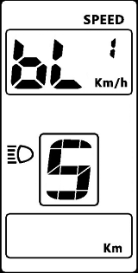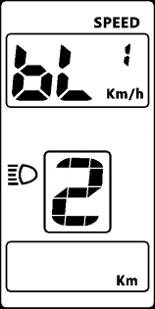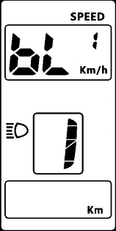
  - Auto off time : The location of speed displays symbol OFF, press UP/DOWN button to change the value from1 to 9, the number represent delay time (minutes) before display shutdown automatically, default value is 5 minutes.
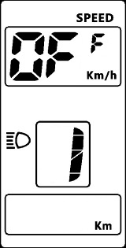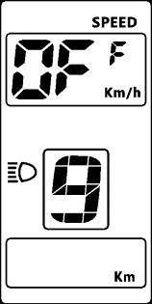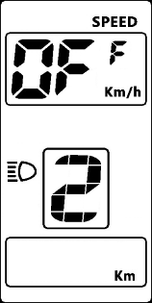
  - Wheel diameter : The location of speed displays symbol Wd, press UP/DOWN button rotate display the symbol 16/18/20/22/24/26/700C/28/29, value represents the diameter of the wheel (inch). Wrong value for wheel diameter will cause speed&mileage abnormal.
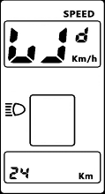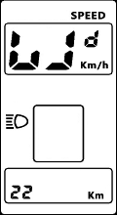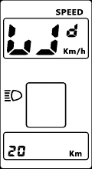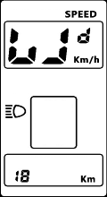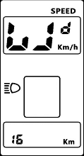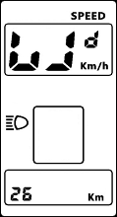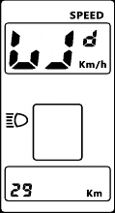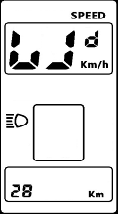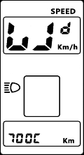
  - .Voltage set : The location of speed displays symbol bU0, press UP/DOWN button rotate display the symbol 24V/36V/UbE, UbE means user-defined voltage setting, this parameter can be set through computer.
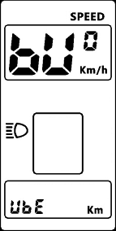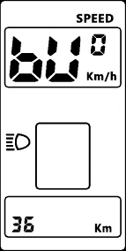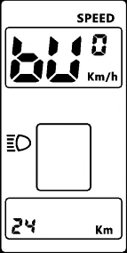
  - Password/Speed limit set : The location of speeds displays symbol PSd, require to input passwords, press UP/DOWN buttons to change the password value (0~9), short press POWER button to switch the password item, password is 4 digits, the default password is "1919". Press POWER button when password adjustment is completed. Display will return to the Voltage set item if the password is incorrect. Correct password will enter the Speed limit set item.
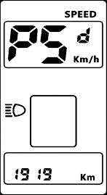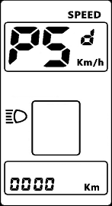
  - Speed limit set : The location of speed displays symbol SPL, the location of mileage displays speed limit value, the default value is 25km/h. Press UP/DOWN buttons to modify the value, the value can be set from 10 to 45km/h. Press POWER button to confirm when you finish the adjustment.
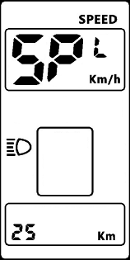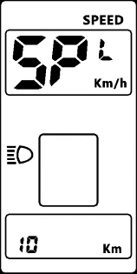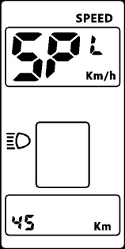
The maximum speed is restrict by the motor and controller, probably couldn’t reach the setting value.
- Error Code define
800S display can give warning message when E-bike exist error, LCD display  icon and the error code in speed position, error code is from 01H~FFH, the definition see the table below.
Error Code | Error description | Error diaplay
0x01 | Normal | No error
0x03 | Brake signal | No error
0x04 | Throttle on high position | Display 04H on speed position
0x05 | Throttle error | Display 05H on speed position
0x06 | Low voltage protection | Display 06H on speed position
0x07 | High voltage protection | Display 07H on speed position
0x08 | Motor’s hall sensor error | Display 08H on speed position
0x09 | Phase line of motor error | Display 09H on speed position
0x10 | Controller over temperature | Display 10H on speed position
0x11 | Motor over temperature | Display 11H on speed position
0x12 | Current sensor error | Display 12H on speed position
0x13 | Battery’s temperature sensor error | Display 13H on speed position
0x14 | Motor‘s temperature sensor error | Display 14H on speed position
0x15 | controller‘s temperature sensor error | Display 15H on speed position
0x21 | Speed sensor error | Display 21H on speed position
0x22 | BMS communication error | Display 22H on speed position
0x23 | Head light error | Display 23H on speed position
0x24 | Head light sensor error | Display 24H on speed position
0x25 | Torque sensor error-Torque | Display 25H on speed position
0x26 | Torque sensor error-speed | Display 26H on speed position
0x30 | Communication error | Display 30H on speed position
0x24 | Head light sensor error | Display 24H on speed position
0x30 | Communication error | Display 30H on speed position
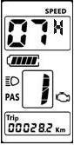
- Assembly instructions
Please pay attention to the screw’s torque value, damaged caused by excessive torque is not within the scope of the warranty.
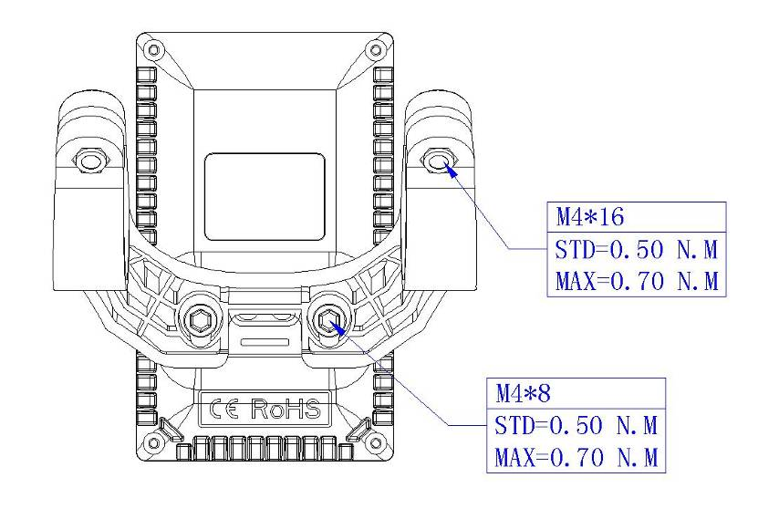
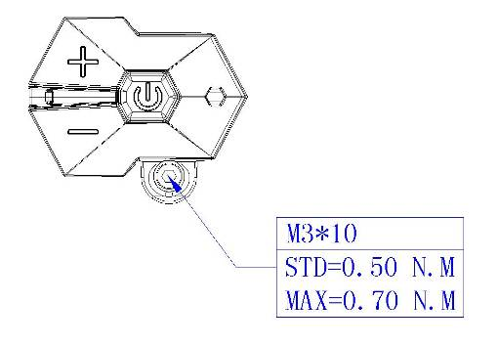
There are 2 directions for the clamp installation, forward or backward.
Different assembly methods will need different cable length.
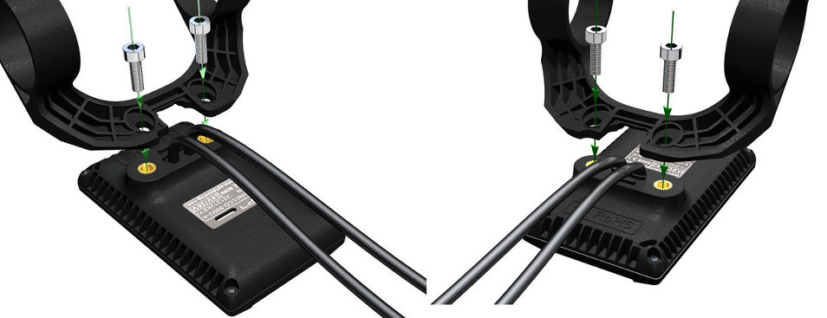
Clamps suit for 3 size of handlebar, 31.8mm, 25.4mm, 22.2mm, there are transfer rings for 25.4mm and 22.2mm, transfer ring must be assembled with the special directions, pay attention to the green arrow below.
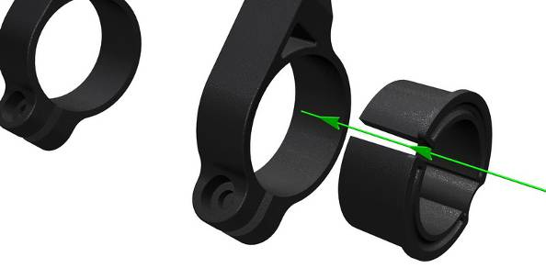
- Output wire instructions
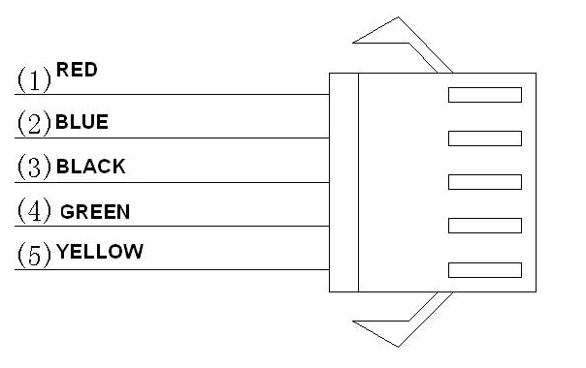
- Red wire : Anode(24v/36v)
- Blue wire : Power cord to the controller
- Black wire : GND
- Green wire : RxD (controller -> display)
- Yellow wire : TxD (display -> controller)
- Assist level instructions
Assist level can be customized, the highest level is 9, common used level see the table below:
3 level | 5 level | 9 level
0 |  | 0 | No power assist
 | 1 | 1
 |  | 2
1 | 2 | 3
 |  | 4
 | 3 | 5
2 |  | 6
 | 4 | 7
 |  | 8
3 | 5 | 9
- Certification
CE / IP65 (water proof) / ROHS.

