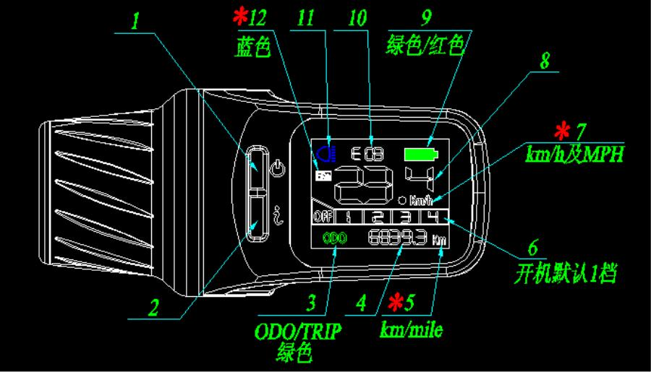


XH18-LCD Display Manual
Turn on the display for operating interface
1.
1.
Power button/front light button. Press to turn on the
display. Interface starts with“welcome” and then gets into
operationinterface.Longpress toturnoff.Screenshutoffafter
showing“thank you”.
2. Press to switch between single mileage and total mileage.
3 . ODO is total mileage. TRIP is single mileage. Default is ODO.
4. Mileage figure
5. Mileage unit Km/h or Mile/h.(MPH)
6. Power assist Levels. Switch throttle for levels change from 1
to 4.
7. Speed indicator. Default unit is Km/h. Press
simultaneously for set-up to switch between Km and Mile.
and

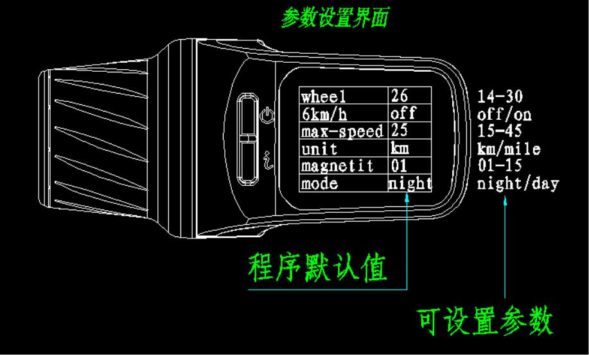
8. Speed indicator figure.
9. Power indicator. Green color for normal and red color for power
shortage.
10. Erro indicator. Erro code for specific malfunction. Red color
11. Front light indicator. Default is close. Press
on/off front light.
to turn
12.Walk assisance (6km). Default is close. Turn throttle in-wards
for 2 seconds to turn on Walk assistance function. Loose the
throttle to close.
Note: Set-up to be done for * items.
2. At operating interface, press and simultaneously for set-up.
1. Enter set-up interface.


2. Press to back and return to operation interface. Press to
set up.
3. For example：After entering the set-up interface, default is to
setupwheelsizes.Switchthrottletoincreaseorreducesizefigure.
Press
to set up Walk assistance function (6km/h). Switch
throttle for on/off choices. Press
interface.
to return operation
6km/h
off/on
unit
mode
km/mile
night/day
These three set up using throttle to switch choices.
Night/day choice for different back lights.

